**Quest For Care: Composting and Mulching Orchards**

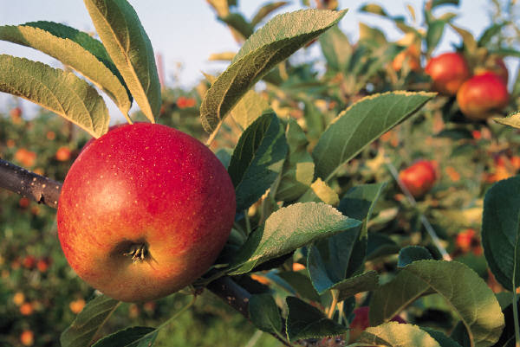

**Group Name**_________________________________________

We want to keep our orchard natural like the forest. What steps do we take to mimic the forest ecosystem? Form groups and answer the following questions to get your materials.

**Site Assessment Observations:** 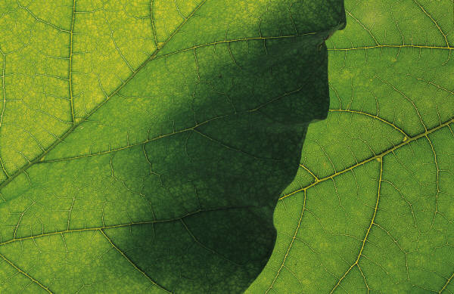

1. List signs that decomposition has taken place

2. Deduct what decomposers are present if none are seen and draw any scavengers

**Decomposers:** _________________________________________________________________

___________________________________________________________________________________

___________________________________________________________________________________

**Scavengers:**

|  |
| --- |
|  |

**Soil**

3. List the properties of the soil, i.e., color, size, texture. Decide if the soil is healthy or not and explain why

**Healthy or not?** _____________________________________________________________________________

_____________________________________________________________________________

_____________________________________________________________________________

**Compost:**

Compost is decomposing plant or animal matter that is used for fertilizing (adding nutrients to the soil). The orchard needs regular nutrients to grow. Compost needs to be added 3-4 times a year. 

4. What can you do to build the humus layer in the soil?

5. Examine the compost. What is in it? Guess what nutrients are in it for the trees?   
 

Nutrients? ______________________________________________________________________

__________________________________________________________________________________

|  |
| --- |
| 6. **Action:** Apply compost to the tree. Find the area where you think the most roots are growing. Push mulch aside and apply compost directly to the soil. |

**Water Requirements:**

Water is necessary for decomposers to do their job and the soil food web to feed tree roots. Tree roots grow where water is. Roots go deep where the water stays during the summer. If watering occurs infrequently, tree roots go deeper seeking out water. Roots grow shallow and stay closer to the surface when hand watered.

7. Are the trees hand watered or is there a drip system or sprinkler? How do you know?

______________________________________________________________________________________________________________________________________________________________________

8. Feel the soil and dig down a bit. Deduct what type of root system the trees have, i.e., deep or shallow? Why?

______________________________________________________________________________________________________________________________________________________________________

**___________________________________________________________________________________**

|  |
| --- |
| 9. **Action:** Apply water where you just spread the compost so that the compost integrates into the soil. |

**Mulch**

In a healthy forest, you always find rich humus created from a build up of leaves, bark, and twigs. This is mulch. Leaf litter acts as compost and mulch. In a human made forest such as an orchard, there is not enough natural leaf litter to play this role since it had been cleared away. This is why mulch is added.

Mulch aids in keeping weeds from growing, holding in moisture, and adding in nutrients through the decomposition process. Moisture is important for decomposers to break down materials. It is important to keep weeds out as they compete for water and nutrients. Mulch also protects the soil from exposure to things such as heat.

Mulch is any plant debris such as wood chips or shreds, grass clippings, animal manure, pine needles, straw, or mixed green waste such as leaves.

10. How can this help the orchard?

_________________________________________________________________________________________________________________________________________________________________________________________________________________________________________________________

11. Examine the mulch. What is the mulch made of?

12. How do you think mulch will break down?

13. If mulch has been applied before, observe and describe what has happened to the mulch.

14. Describe what soil is there.

15. Compare the mulched area to a nearby area that has no mulch. Describe the differences you notice.